Backscatter Processing SOP: Kongsberg EM 2040/EM2040C/EM 710

1. Plan survey lines. Lines should be approximately 300m in length, over a flat and sandy area in 30-60 m water depth. It is **critical** that all vessels used in this normalization collect over the **same area.** If a sonar cannot collect data in an area for any reason, it is insufficient to collect backscatter data in a different area and integrate it into this dataset. This normalization only works to compare the mosaics between each sonar, given that all other conditions are similar as possible (survey area, weather, etc).
2. Collect survey lines (16 total). Each line should be gathered in each direction (reciprocal heading). Studies have found that heading can impact the backscatter mosaic, as well as environmental factors (chop). Collecting in each direction ensures a redundant dataset to work with in the event one is significantly impacted by heading/environment. Take care to keep a detailed acquisition log, in order to track which lines are acquired with each parameter. If there is significant beam fraying, limit the sonar degrees so that all frequencies have a clean edge.
   1. 200 kHz: SP, LP, FM: 6 total
   2. 300 kHz: SP, LP, FM: 6 total
   3. 400 kHz: SP, LP: 4 total
   4. EM2040C: 200-400 kHz: Very Short CW (VSP), Very Long CW (VLP), Extra Long CW (ELP): 18 Total (not currently in spreadsheet)
   5. *FOR EM710 40-700 kH: Ping Mode: Very Shallow (VS), Shallow (S), Medium (M), Deep (D) Very Deep, (VD), Extra Deep (ED): 12 total* (not currently in spreadsheet)
3. Import and process the lines with FMGT, with typical backscatter processing parameters. It is useful, but not critical, to import the HDCS lines for this process. This gives more accurate XYZ data for the mosaic, but it’s really the decibel intensity we’re interested in comparing here.
4. (Please follow the following naming convention so that future automation is easier) Create a mosaic for ***each individual line***. **Rename** the mosaic with the following info: vessel name(VVVV), sonar frequency(###kHz), sonar pulse length(NN), and heading(###). VVVV_###kHz_NN_### Example: **S222_200kHz_LP_180**.
5. Export each mosaic as a Surface.

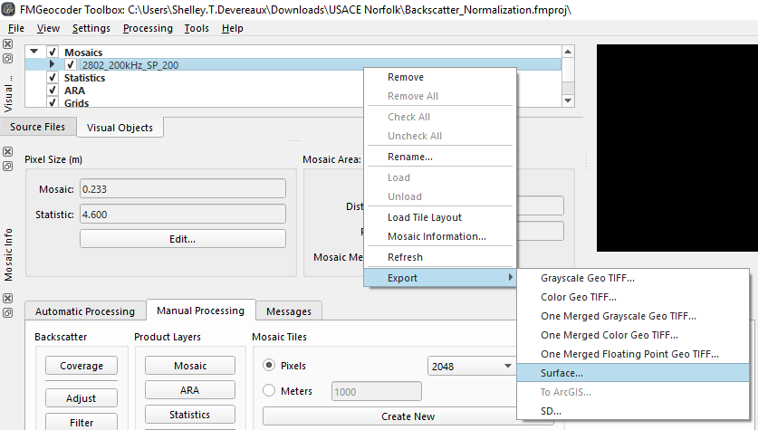

1. Use Decimal Precision: 2, and Separator: Comma. Unfortunately, the program does not automatically pull the name from the file, so you’ll have to re-enter the file name here. Use the same VVVV_###kHz_NN_### format.

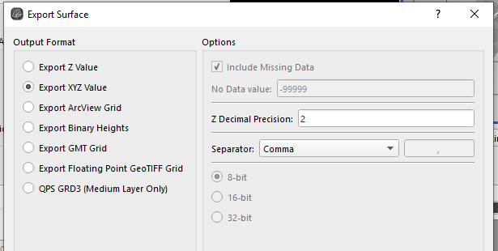

1. After you have exported all the mosaics in this format, sort the .xyz files by the frequency, direction, and place each frequency/direction into a separate folder. DO NOT SEPARATE BY VESSEL

ex: 200 kHz, 300kHz, 400kHz

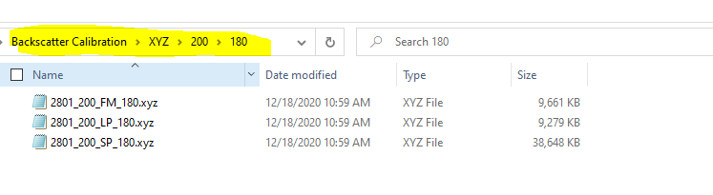

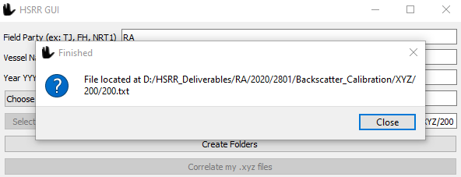

1. Open the HSRR Helper (within Pydro). Select the frequency you wish to calibrate. The GUI will place the results into the same file you selected to calibrate. Press the button Correlate my .xyz files. The GUI will show three stars over the same button as it calibrates. Once done it will show a dialogue box showing the folder the .txt file was placed in. Repeat this process for the remaining frequency folders.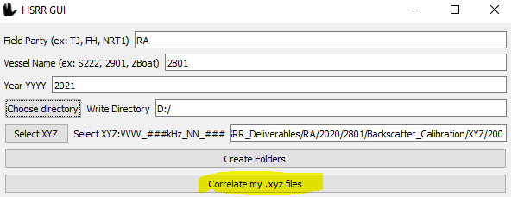

8*) Repeat this process for each direction and compare the results. They should be near the same answer. If they are not this could be a result of swell or other issues. Reason being - heading has been found to have an influence on the results, so you always want to compare same/same. If you're going with the swell, it tends to have less acoustic interference than if you were going into the chop. There's also the possibility that the particular angular refraction of the bottom type could look different based on how the sonar hits the seafloor one direction, vs the other, but this is really only true for rocky bottom type areas. Sandy or fine gravel shouldn't introduce this particular issue. We gather lines in both directions as a redundancy step, in case the results for one heading don't look so great

1. Open the .txt files and enter the values into the [spreadsheet](https://docs.google.com/spreadsheets/d/1mbp1gonEzPjvKW53P7aj0FxUSKz6lJL72HkMie97GFU/edit?usp=sharing). (Please COPY the spreadsheet and do not edit the primary copy)

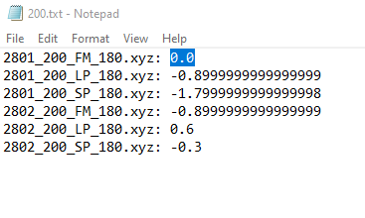

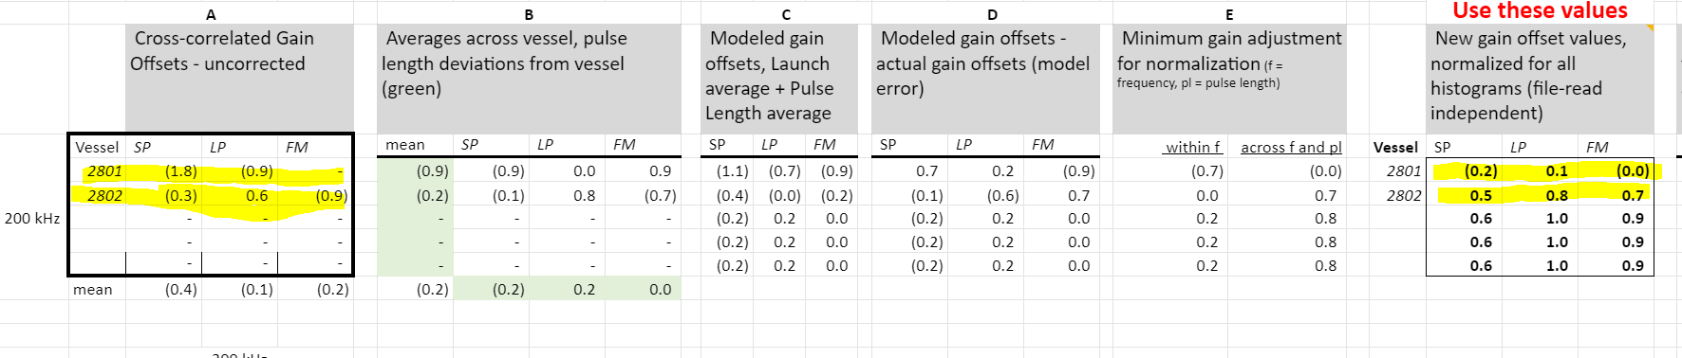

1. Back at FMGT, create a new vessel/frequency profile (or vessel and frequency) under the **Settings > Add Processing Settings** menu. Go back into the same menu to edit this profile. Yes, this one is only “2804” but it should be “2804_200kHz” or something like that. (Save this file for submission)

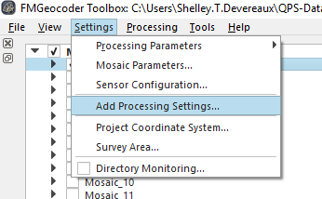 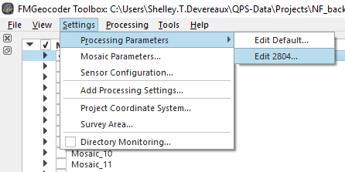

1. Input the vessel profile values for each pulse length under Processing Parameters > Vessel/Frequency > Format. There will be extra pulse length entries – just use FM for the two FM ones, Short for Very Short/Short, Medium for Medium, and Long for Long. Very Long and Extra Long do not apply.

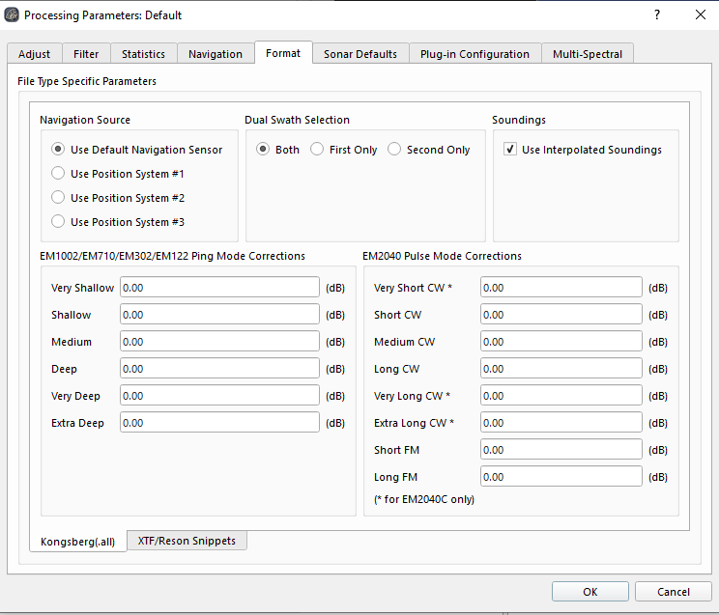

1. Test with your lines! Process the lines with the appropriate vessel setting. Do they match up? If there’s significant mismatches, there’s a chance the signs were flipped for the vessel profile settings.